Extra Credit: Field of Valor
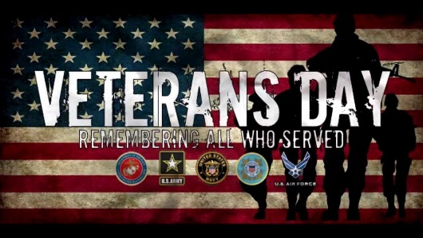
Covina Rotary will host the sixth annual Field of Valor at Sierra Vista Middle School (777 E. Puente St., Covina) from November 6 – 12, 2016. The field will be open daily until 9 pm. ADMISSION IS FREE. Proceeds from the event will benefit Veterans, Active Duty Military and their families, and the Ontario USO. www.covinarotaryfieldofvalor.org
Task:
1. Find a flag honoring a veteran and take a selfie next to the flag in the field of valor.
2. Post the picture on Instagram with the hashtags of the veteran’s name and branch of service; veterans day 2017; and 2 more of your creation.
3. Send me a screen shot of the post through Remind. MUST BE RECEIVED BY 9 PM ON NOV. 12TH!!

