THE VIETNAM WAR

TASK: Annotate each paragraph explaining how the Vietnam War progressed both on and off the battle field. Answer essential questions at the end of each topic. YOU MAY WRITE ON THIS‼

STEPS:
- Read each section. Highlight key vocabulary words, key people, outcomes on the topic of the paragraph.
- In the righthand margin next to each paragraph, write a one sentence recap of the main idea from the paragraph.
- In the lefthand margin next to each paragraph, write an emotion you felt or question/comment you thought of while reading the paragraph.
- Answer the essential questions that follow each topic.

Johnson’s Approach to Vietnam

Vice President Lyndon Johnson became president after President Kennedy’s assassination on November 22, 1963. Johnson’s advisors immediately pressured him to increase military aid to the increasingly unstable South Vietnamese government. Taped phone conversations reveal that Johnson had grave misgivings about American involvement in Vietnam. Despite Johnson’s private doubts, he felt great pressure to deepen U.S. involvement in Vietnam. Above all, Johnson did not want to appear weak against communism. He felt it was necessary to continue his predecessor’s strongly anti-communist rhetoric and policies. Johnson was concerned that if he pulled the United States out of Vietnam, Congress might turn against him. Johnson also felt his political ambitions for the future were in jeopardy. He was afraid that if he appeared “soft” on communism, he would not be reelected president in 1964. Therefore, in 1964, Johnson began to send more troops into Vietnam.

EQ1: If President Johnson had such grave misgivings about America’s involvement in Vietnam, then why did he send more troops?

EQ2: Do you agree with Johnson’s actions of sending more troops, why or why not?

Gulf of Tonkin Incident

The Gulf of Tonkin incident in the summer of 1964 officially pulled the United States into the Vietnam War. The United States hoped to eventually attack North Vietnam by air and sea. To prepare for these attacks, in 1964, the United States conducted covert intelligence missions in the Gulf of Tonkin. The aim of these missions was to determine the extent of North Vietnam’s defenses, some of which were now being provided by the Soviet Union. On August 2, 1964, the USS Maddox, clashed with North Vietnamese patrol boats in the Gulf of Tonkin. The United States refused to retreat claiming the United States had “legitimate rights in [the gulf’s] international waters.” President Johnson claimed North Vietnamese “attacked” the USS Maddox and the “attack” was unprovoked. This justified Johnson’s ordering of bombing strikes on North Vietnam and moving the U.S. from an advisory role to a full-scale military involvement.

Gulf of Tonkin Resolution

Johnson seized the opportunity from the Gulf of Tonkin incident to send a pre-planned resolution to Congress. The “Gulf of Tonkin Resolution” gave the president the right to “take all necessary measures” to defend any nation in Southeast Asia threatened by Communist “aggression or subversion.” The resoltuion pass through Congress almost unanimously, with only two senatorss dissenting. The resolution gave President Johnson broad military power; he had the legal right to send troops into Vietnam without an official U.S. declaration of war. South Vietnam’s new leader, Nguyen Khanh, was more than willing to accept U.S. assistance as his government was being threatened by the increasing success of the Viet Cong, the Communist rebels in South Vientam.

EQ4: Why should Americans be concerned over the passing of the Gulf of Tonkin Resolution?

Johnson Escalates the War

In 1965, President Johnson addressed the nation: “I have asked the commanding general, General Westmoreland, what more he needs to meet this mounting aggression [in Vietnam.] He has told me. And we will meet his needs. We cannot be defeated by Communist bullies. We will stand in Vietnam.” After the Gulf of Tonkin incident, the U.S. conducted air raids on North Vietnam and began bombing the region on a regular basis in early 1965. Later that year, the first American combat troops arrived in the South Vietnamese city of Da Nang. By December 1965, there were nearly 200,000 combat troops in South Vietnam. In 1966, Johnson sent another 200,000 troops, and by the end of 1967, America had 500,000 troops in Vietnam.

EQ5: Describe the military strategy to defeat the enemy that President Johnson is attempting to implement between 1965 – 1967.

Guerilla Warfare

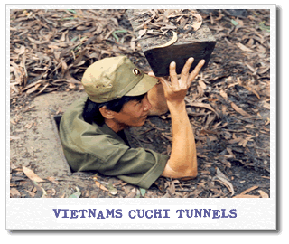
The fighting in the Vietnam War was unlike anything U.S. troops had previously experienced. First, Vietnam’s wet, often dense jungle terrain made movement difficult and very uncomfortable with the high humidity and monsoons. As one Vietnam veteran recalled: “For most American troops, the War was endless plodding across flooded rice fields and tangled jungle trails in search of an elusive enemy. Most often, the soldiers were harassed more by heat and leeches than by the communists.” In addition, to offset their military inferiority, North Vietnamese and Viet Cong troops used various guerrilla tactics to attack U.S. forces. For example, they often tried to “cling to the enemy’s belt” – a term for engaging in close combat so that Americans could call in air and artillery strikes only at the risk of endangering their own troops. Vietnamese fighters also darted out of tunnels and bunkers to ambush U.S. patrols and used an ingenious assortment of land mines and booby traps. One soldier recalled the effectiveness of Viet Cong mines: “The VC [Viet Cong] set off 10 mines, which were spread out on the trail under us. When they all went off at once, every man in the patrol was hit . . . the corpsman who was behind me was killed instantly; [the] squad leader right in front of me lost both his legs from the knees down and was screaming bloody murder . . . I have never been so damned scared in my life.”

EQ6: Assess the various difficulties American troops encountered in the Vietnam War.

Effective Vietnamese Forces

Despite the dangers of fighting a guerrilla war in the jungles of a nation half a world away, the U.S. government was confident that it could defeat the Vietnamese with a superior show of military force. During the war, American bombers dropped approximately 3.2 million tons of explosives on the Vietnamese countryside. However, Viet Cong rebel Ton That Tung reported: “The Americans thought that the more bombs they dropped, the quicker we would fall to our knees and surrender. But the bombs heightened rather than dampened our [fighting] spirit.” In addition, large North Vietnamese and VC fighting units went into actual combat infrequently. Instead, they preferred to engage in hit-and-run maneuvers, so they could choose the terrain for battle and avoid direct confrontations with the superior U.S. military. Furthermore, unlike the Americans, the Vietnamese forces were very familiar with the local terrain, which gave them the advantage in most engagements.

EQ7: Differentiate between the U.S. strategy and North Vietnamese (Viet Minh) and Viet Cong strategies used in the war?

Friend or Enemy

Another difficulty U.S. troops faced in the Vietnam War was attempting to distinguish “friends” from enemies. In South Vietnam, where the people were assummed to be allied with the Americans, soldiers could not always differentiate between hostile and friendly peasants. In fact, many South Vietnamese did not welcome the presence of the U.S. troops. One U.S. lieutenant commander noted: “The enemy in our area of operations is a friendly farmer by day and VC by night.” A Marine captain stated: “You never knew who was the enemy and who was the friend. Here’s a woman of 22 or 23. She is pregnant, and she tells an interpretor that her husband works in Da Nang and isn’t VC. But she watches your men walk down a trail and get killed or wounded in a booby trap. She knows the booby trap is there, but she doesn’t warn them . . . The enemy was all around you.”

U.S. Troop Disilluionment

In the beginning of the war, many U.S. soldiers believed they were fighting for a good cause: to halt the spread of communism and win the “hearts and minds” of the Vietnamese people. As one soldier wrote: “Wherever we were, we had to win over the [Vietnamese] people if we wanted to accomplish our mission . . . [American soldiers] are willing to fight in this country where the people have really never known what a free society is like. Every American should know by now that the war we’re fighting in South Vietnam is a war against communist aggression, which is an ever-present threat to the free world today.” However, morale among the American troops began to decline as the war progressed and no major gains were held. A U.S. marine confessed: “After a few months [in Vietnam], it began to seem crazy as more guys were dying. Maybe we Americans weren’t the good guys being the heroes. Maybe we shouldn’t be in Vietnam. Maybe I’d gotten my butt out in these bushes for nothing.” Another soldier wrote to his father: “[Vietnam] is no gain that I can see, Dad. We’re fighting, dying, for a people who resent our being over here . . . I guess I’m bitter now, Dad. This war is all wrong.”

EQ8: Evaluate how the mind set of some U.S. troops changed from what it was at the beginning of the war?

The Vietnamese “People’s War”

The Vientamese Communists (Vietminh) called their war a “people’s war” against South Vietnam and received widespread support in both North and South Vietnam. As one historian noted: “The Vietminh were outnumbered and outgunned, with no modern equipment to speak of. Their sole advantage was determination.” Ho Chi Minh, the leader of Communist North Vietnam, appealed to the Vietnamese people’s intense national identity and linked the Communist struggle with Vietnam’s long history of resisting outsiders. One North Vietnamese civilian recalled: “The Communist Party built in us a great patriotic feeling. Our national hereos had loved freedom and were ready to sacrifice everything for it. That feeling got instilled into us, into our bones . . . there wasn’t a single schoolboy who didn’t have total confidence in the Party’s leadership and credibility. I wanted to do anything I could to save the people in South Vietnam.” The Communists made horrendous sacrifices in lives to attain their long-range objectives. At least half a million of their troops died in action, yet there were always new recruits to replace the casualities.

EQ9: To what extent did nationalism play a part in the Vietnam War?

U.S. Air War

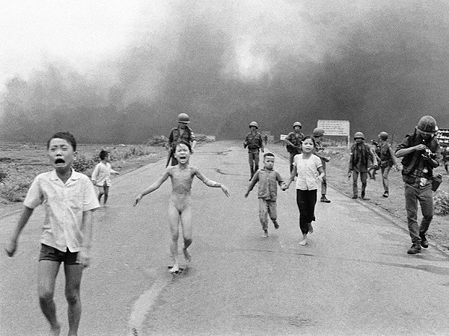
U.S. troops would conquer territory by launching massive air assaults, only to have the Viet Cong sneak back in after the bombing. As a result, U.S. bombings did little to halt the tenacious Vietnamese forces. The U.S.’ enormous firepower killed countless Vietnamese, but the tactical triumphs failed to add up to a victory. Air raids destroyed entire villages and laid waste to surrounding landscapes. Nine percent of the bombs the U.S. dropped were napalm bombs. The bombs contained a jellylike chemical mixture that burned whatever it touched. A Vietnamese villager recalled the horrifying scene after the U.S. bombing of Dai Lai: “When we got to the village, it was so awful that we were in a state of shock. The village had been hit by napalm. More than half of it was burned. Hundreds of people were dead and many others burned terribly but still alive. Some children were burned over half of their bodies and were screaming and crying. I saw one small child’s body in a bunker that was still glowing. The body looked like a blackened pig. I was so scared I couldn’t move.” As word of such bombings reached the United States, it only added to the increasing unpopularity of the war.

EQ10: Given what you have learned about the Vietnam War so far from these readings, what goal is the U.S. trying to achieve with the use of the air power?

EQ11: What ethical/moral questions come to mind over the use of the air power?

The Ho Chi Minh Trail

One important advantage Ho had over the United States was the use of a series of complex paths and roads known as the Ho Chi Minh Trail. The trail ran from North Vietnam to South Vietnam via the neighboring western countries of Cambodia and Laos. Virtually undetectable from the air due to dense jungle cover, the trail was a key means of transporting military equipment and troops from North Vietnam to the VC in the South. U.S. forces could not attack the Vietnamese Communists in neutral Cambodia and Laos because, as Defense Secretary Clark Clifford explained: “President Johnson had forbidden us from pursuing the enemy into Laos and Cambodia because that would widen the war, geographically and politically.” As a result, the United States attempted to bomb Vietnamese forces traveling on the trail, but the air raids were largely unsuccessful. Therefore, Ho’s troops were able to bypass U.S. forces and enter South Vietnam in relative safety.

EQ12: To what extent did Ho Chi Minh’s use of the trail outmanuever the U.S.?

Unpopularity of the War

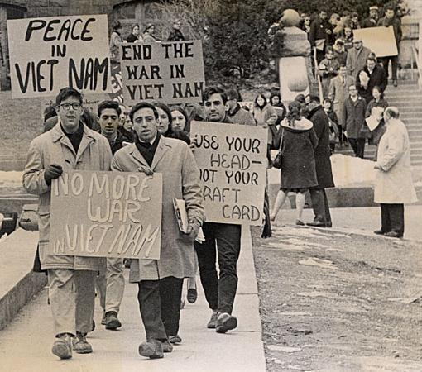
The Vietnam War became increasingly unpopular with the American public for a variety of reasons. First, John’s escalation of the war by sending hundreds of thousands U.S. troops into Vietnam had the corresponding effect of escalating the number of Americans killed. Second, unlike World War II, in which Americans believed they were fighting a “good war” against clearly evil enemies, many Americans grew uncertain as to why the United States was involved in Vietnam. Many Americans found it increasingly hard to understand why American lives were being lost in what amounted to another country’s civil war. Finally, horrifying images of the war in magazines, newspapers, and on television served to increase American’s unfavorable view. Secretary of State McNamara recognized this when he reported: “Pictures of the world’s greatest superpower killing or seriously injuring 1,000 noncombatants a week, while trying to pound a tiny backward nation into submission on an issue whose merits are hotly disputed, is not a pretty one. I’m not sure how much more Americans and the rest of the world will permit the United States to continue to go.” As the war dragged on, famous and respected American leaders began to come forward and publicly condemn the war in Vietnam. Civil rights leader Martin Luther King, Jr. said in 1967: “ Somehow this madness must cease. We must stop now . . . If we do not act, we shall surely be dragged down the long, dark and shameful corridors of time reserved for those who poosess power without compassion, might without morality, and strength without sight.” College students and professors began holding sit-ins and teach-ins, in which people discussed the Vietnam War and protested U.S. involvement. Antiwar demonstrations began in 1965. Protestors carried signs expressing sentiments as “War is a dirty word” and “Peace” featuring doves. One famous protest chant accused President Johnson, “Hey! Hey! LBJ! How many kids did you kill today?” By the end of 1967, antiwar demonstrations were practically a daily occurrence at colleges around the antion and massive peace marches were held in major cities.

EQ13: How would you describe the atmosphere in the U.S. during the Vietnam War?

EQ14: How does the atmosphere in the U.S. during the Vietnam War differ from that of World War II? What are contributing factors for this difference?
The Tet Offensive

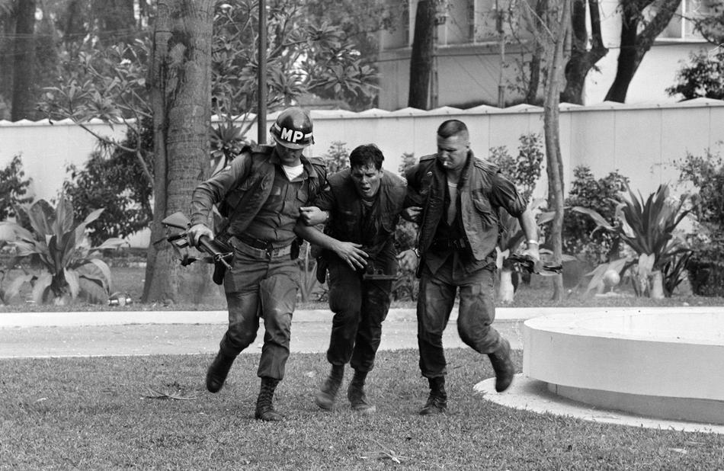
In late 1967, CIA operatives in Vietnam came across a document that claimed Communist forces were planning a “general offensive and general uprising” in South Vietnam. U.S. officials dismissed the document, believing it to be propaganda. In January 1968, the U.S. and Vietnam agreed to a temporary truce during the celebration of Tet, the Vietnamese new year. But on January 31, 1968, 70,000 Communist soldiers launched a surprise offensive action of extraordinary intensity on South Vietnam. They surged into more than a hundred cities and towns, including the capital of Saigon. The attack took the U.S. completely by surprise and shifted the war for the first time from its rural setting to supposedly impregnable urban areas. Communist commandos even attacked the U.S. embassy in Saigon and killed four Marine guards proving that the U.S. was vulnerable despite its immense power. One Marine engaged in intense street fighting in the city of Hue told a television news crew: “Not knowing where [the Viet Cong] are – that’s the worst thing . . . could be anywhere. Just hope you can stay alive, day to day. I lost quite a few friends. The whole thing sucks.” Despite the element of surprise, the Tet offensive was a resounding military defeat for the Viet Cong. By the end of March 1968, 2,000 American Gis had died compared to over 50,000 Communist troops. But the Communist willingness to endure war casualities continued. Viet Cong General Tran Do explained: “In all honesty, we didn’t achieve our main objective [of the Tet offensive], which was to spur uprisings in the South. Still, we incited heavy casualities on the Americans and their puppets and that was a big gain for us.” An even greater gain of the offensive, Do added, was the way the Tet offensive turned the American public against U.S. involvement even more.

EQ15: What alternative decisions could have been made to have prevented the Tet Offensive from occurring? How would those alternative decisions been played out?

The Cost of War

The combination of the Tet offensive, rising casualities, and the increasing cost of the war caused many Americans to question further involvement in Vietnam. A majority of Americans considered Johnson’s stand in Vietnam a “mistake.” Walter Lippman, an influential newspaper columnist wrote: “The division of the country will simply grow as the casualities and costs increase.” Back in 1964, President Johnson had not told Congress or the American public what he and his advisors believed would be the true cost of the war. He later explained that he feared if he told the whole truth, he would not be able to pass his Great Society domestic legislation. Johnson hoped that such legislation would create a “Great Society” based on social justice, economic equity, and racial equality. Johnson assured the American public that the country could afford both the war and its domestic needs. But by 1967, the rising cost of the war forced Johnson to cut $6 billion from the domestic budget and impose an additional 10% tax surcharge on American goods.

EQ16: Evaluate how Americans would characterize their attitude toward President Johnson in 1967?

1968

By 1968, the Vietnam War had been raging for over four years, with no end in sight. However, the U.S. government continued to reassure the public that fighting in Vietnam would soon wind down and that there was a “light at the end of the tunnel.” This assurance became less and less credible as American casualities rose, clear-cut victories proved to be scant, and the cost of the war mounted. What became known as the “credibility gap” was President Johnson and the government telling the American public one thing, but the reality of evidence proved to be saying the complete opposite. From 1968 to 1969, when the war was at its height, over 500,000 American troops were stationed in Vietnam. During that time period, the U.S. dropped almost 1.2 million tons of bombs in 400,000 air attacks and destroyed over 20,000 acres of vegetation. Over half a million Vietnamese became refugees due to military actions and 130,000 Vietnamese civilians perished per month. On the U.S. side, well over 35,000 soldiers had been killed since the beginning of the war.

EQ17: How does the issue of the “credibility gap” add to American’s attitude toward President Johnson?

Johnson Leaves Office

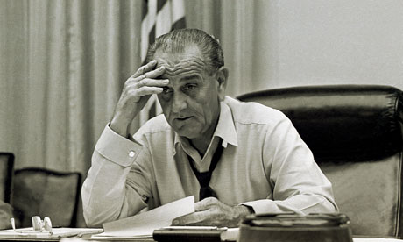
By 1968, Johnson had three choices: he could escalate the war with more troops and heavier bombing; he could continue on the present course; or he could curb the air raids and withdraw U.S. troops from the Vietnamese countryside into the cities, where they would suffer fewer casualities. Johnson’s military advisors pressured him tos end another 100,000 troops into Vietnam. Ultimately, Johnson decided: “there is no reason to believe that the communists could be beaten by an additional 200,000 American troops, or double or triple that quantity.” But Johnson’s decision not to increase U.S. troops in Vietnam was too little, too late to save his political career. Public support for the war had dropped rapidly and Johnson’s approval rating plummeted from 48 to 36 percent in the 6 weeks following the Tet offensive. In a speech to the American people on March 31, 1968, Johnson announced that the United States would decrease bombings in Vietnam and was open to negotiating with North Vietnam. He also announced that he would not run for reelection, stating: “I shall not seek, and I will not accept, the nomination of my [Democratic] party for another term as your president.” The Republicans nominated Richard Nixon whose promise to “end the war and win the peace” won him the presidency in 1968.

EQ18: What realization did President Johnson come to in 1968 that led to his decision to open negotations for a cease-fire with North Vietnam?

The My Lai Massacre

Public outrage over the war in Vietnam continued to mount in Nixon’s first year as president. In late 1969, journalist Ronald Ridenhour revealed that U.S. forces had massacred the village of My Lai in 1968. On March 16, 1968, 30 American soldiers under the direction of Lieutenant W.L. Calley stormed My Lai and fired on the defenseless villagers, killing over 200 women, children and old men claiming their men and sons were VC and they had information to their whereabouts. One soldier recalled: “Just outside the village there was this big pile of bodies [of Vietnamese dead]. This really tiny kid – he had only a shirt on, nothing else – he came over to the pile and held the hand of one of the dead. One of the Gis behind me dropped into a kneeling position thirty meters from this kid, and killed him with a single shot.” The deaths, Calley said, were “no big deal.” The public and the U.S. Army thought otherwise – Calley was eventually court-martialed along with 10 of his commanders for the murders of 109 My Lai villagers. The My Lai Massacre increased the pressure on President Nixon to cease fire and negotiate peace for the war.

EQ19: Pulling on the knowledge that you have learned about the U.S.’ involvement in the Vietnam War, if you were the defense attorney for Lieutenant Calley and his 10 commanders, what argument might you make to defend their action in My Lai?

