A Slave’s Life & Narratives

A Slave’s Life Assignment Steps:
- Title a new spiral page “A Slave’s Life”
- Create a two column chart landscape in your spiral. Title one column “Know”; the other column “Learned”
- Fill in the “Know” column with 5 facts that you ALREADY know about what life was like for a slave. Provide specific details. Think about all aspects of the slaves’ lives.
- Share out knowledge with an aisle partner. Copy down these facts under the “Learned” column.
- Read the Slave’s Life handout. Add additional facts to your “Learned” column.

Slave Narratives Assignment Steps:
- Watch Unchained Memories: Readings From Slave Narratives.
- Copy down the chart below into your spiral.
- Read through the slave narrative.
  - Highlight the slave dialect words
  - Transfer the highlighted words to the chart in your spiral; no need to write repeated dialect words
  - Translate the slave dialect words into standard English dialect
  - Summarize the narrative memory using standard English dialect
- Repeat steps 8a – 8d for each slave narrative.

Author of narrative ___________________________________
Slave Dialect | Standard English Translation | Summary of narrative

Reflective Assignment:
- Choose 1 of the 3 assignment choices below to complete. Be sympathetic and considerate to the nature of this topic!

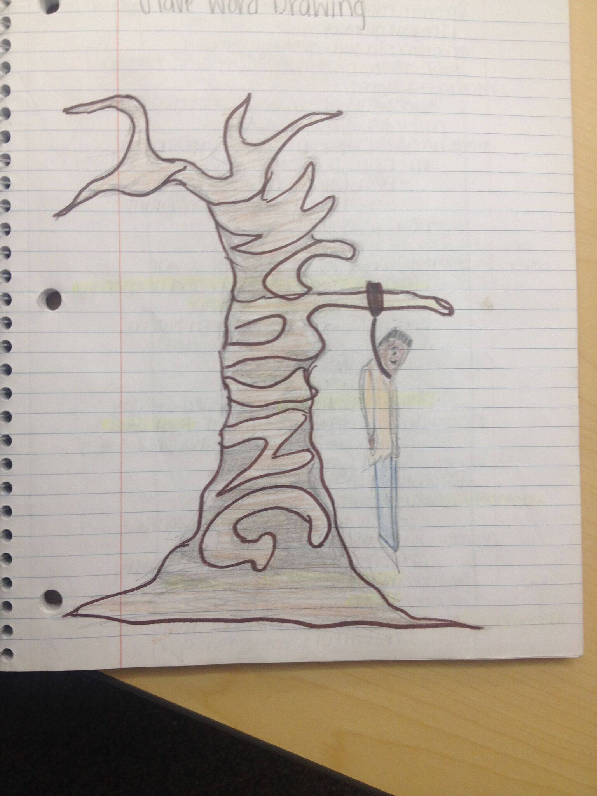
- Illustrated Word - Draw a large-sized colored illustrated word capturing the emotions and/or experience for a slave. See examples below for illustrated word concept. Illustrated word drawing must be colored.
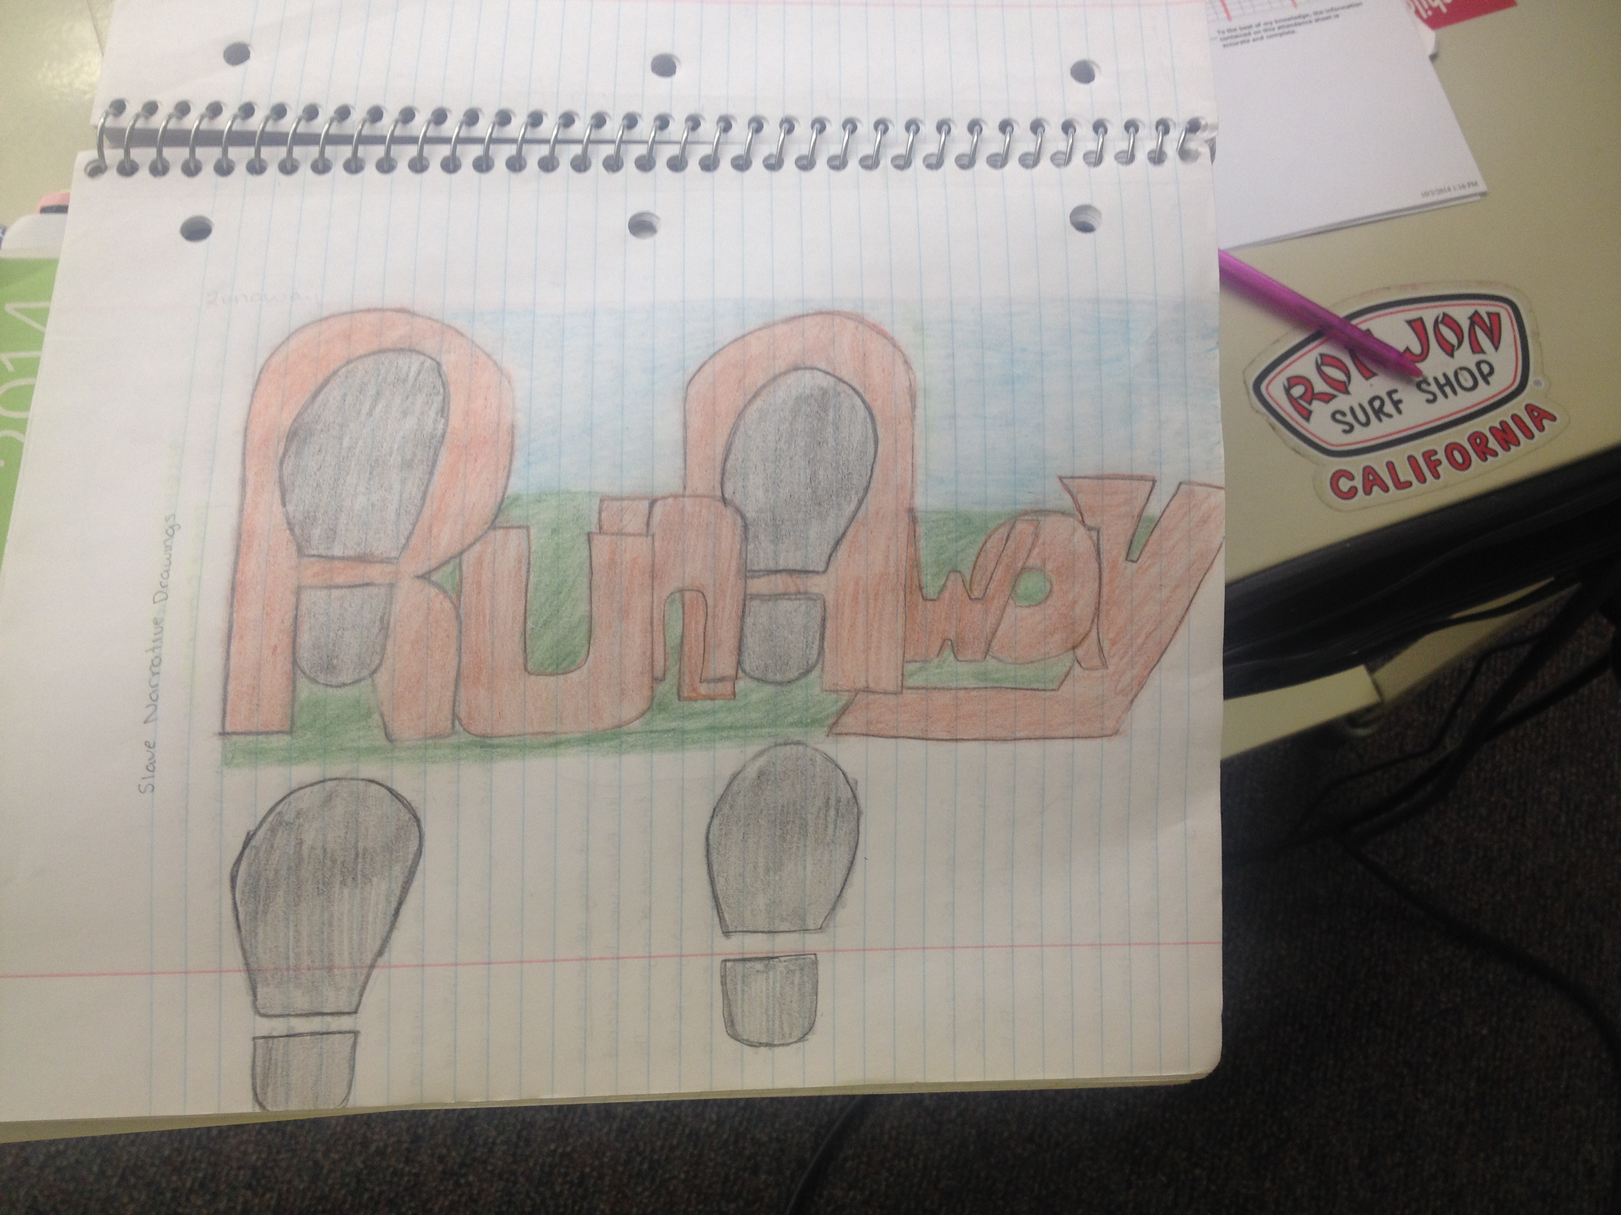
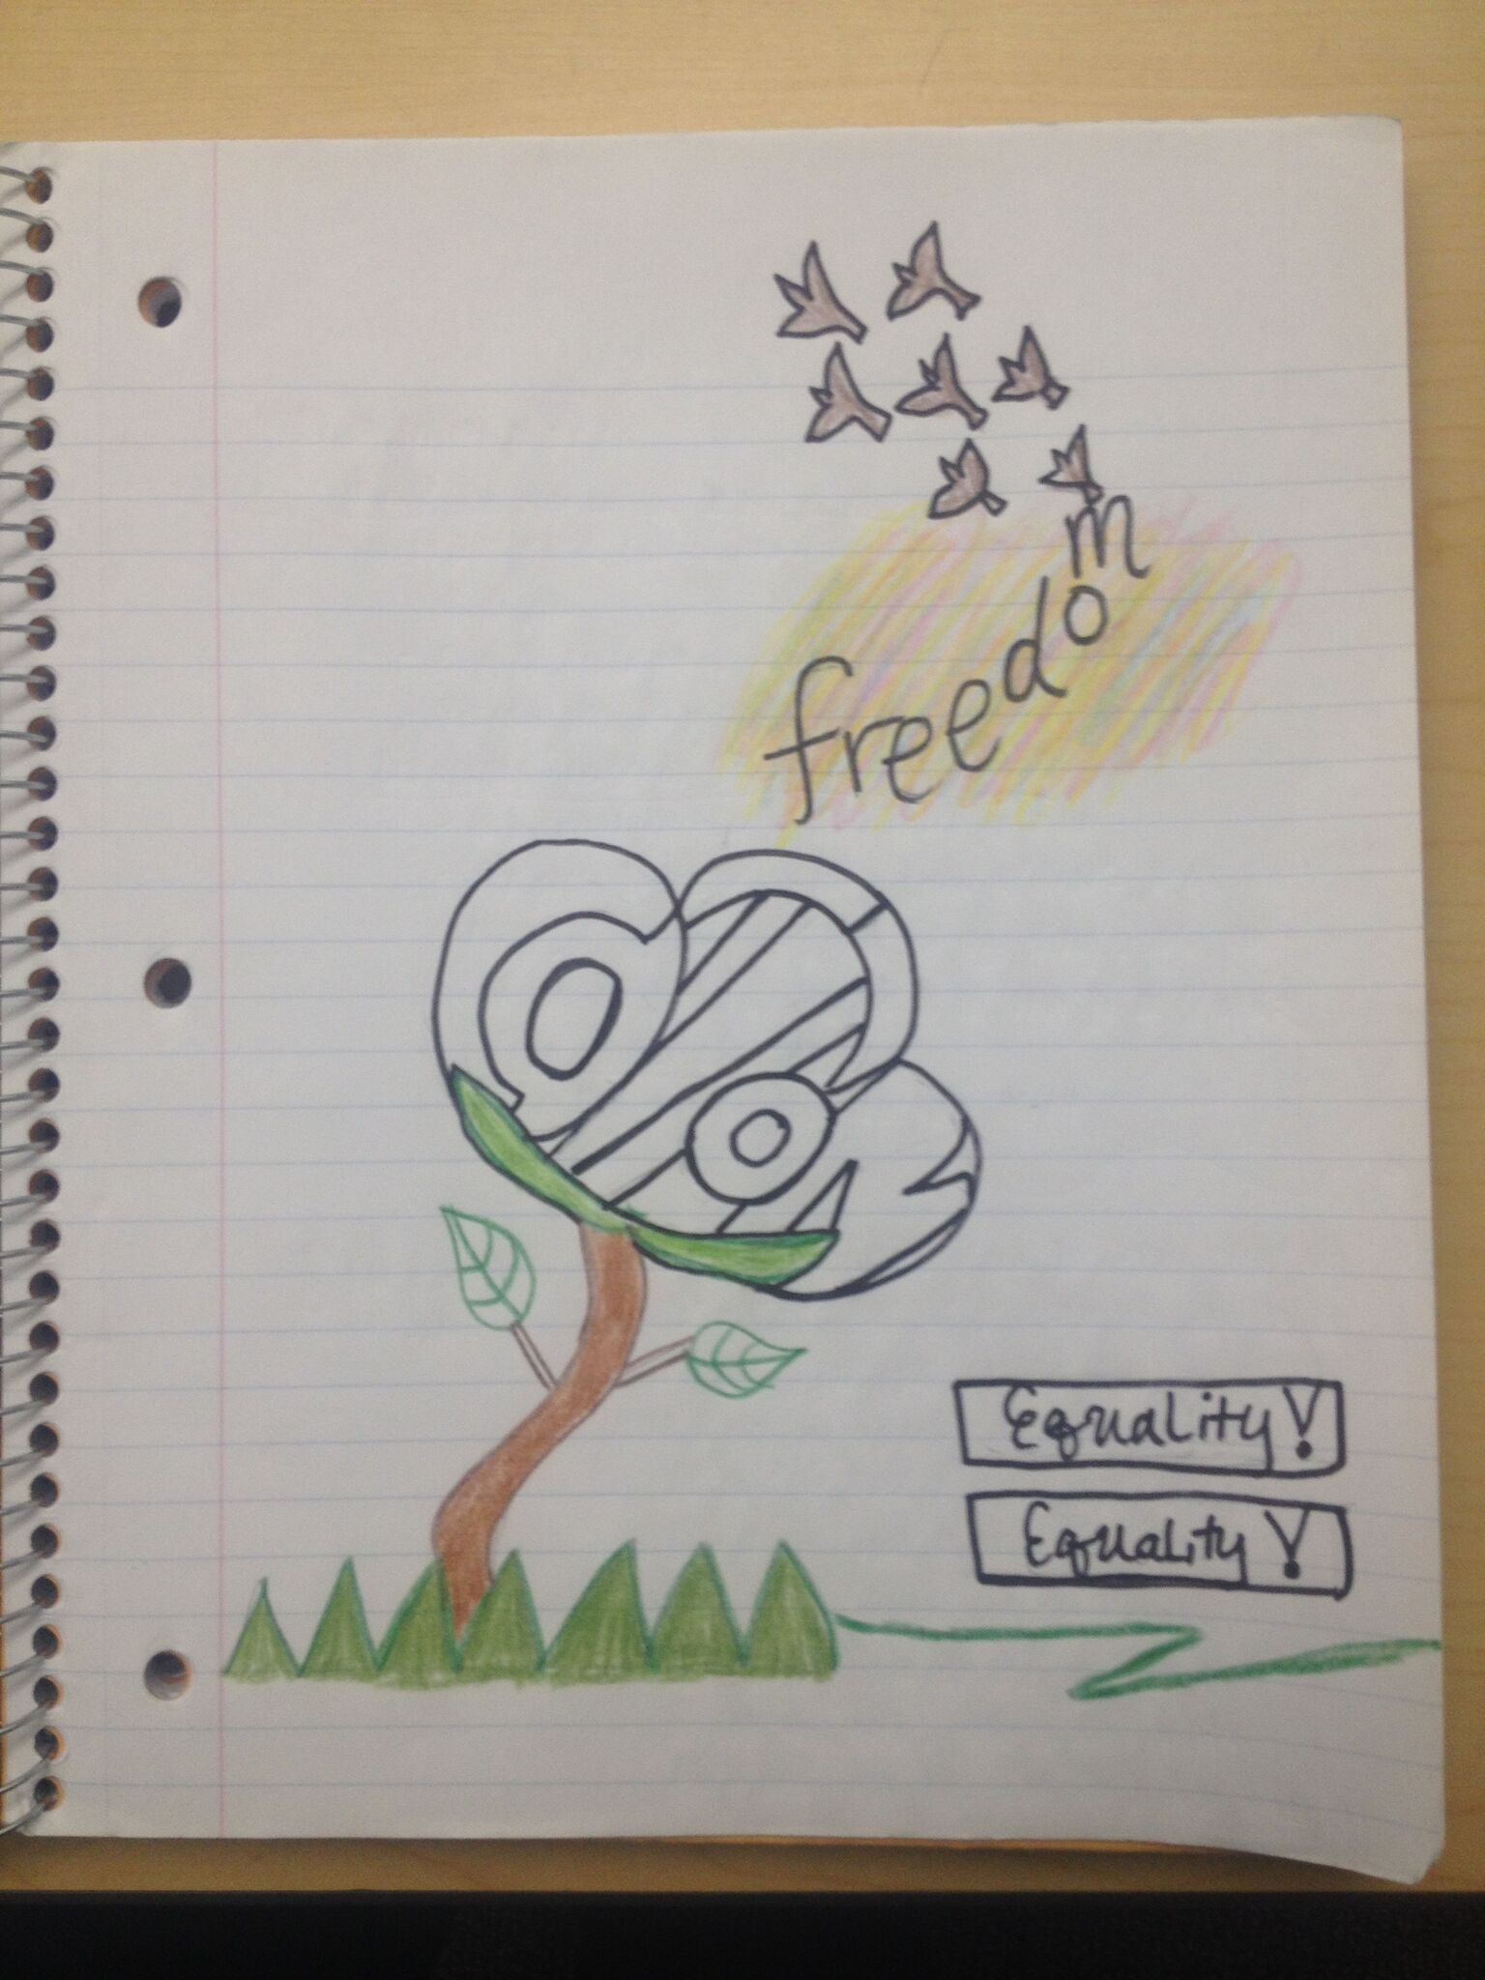

- Be the Thing – A Whip. Write a personal response as if you were a specific object (a whip) from the time of slavery. Your response should include both emotional and physical feelings of the object (a whip). Imagine you are the whip!
  - Be at least two complete paragraphs in length.
  - Describe the purpose and function of the object.
  - Describe how the object might feel or what it might be thinking about the event.
  - Include six facts about the event from the objects point of view.

- Slavery Cinquain – Cinquains are identification poems; these short poems are designed to capture the “main idea” of a person or concept (slavery). Your poem should follow this format:
  - Line 1 – One word (the subject – slavery)
  - Line 2 – Two single-words that describe the subject
  - Line 3 – Three action words (-ing) about what the subject does
  - Line 4 – Four or five historical facts of a slave’s life experience
  - Line 5 – One word that could be another name for the subject (slavery)

