WWI Reflective Assignment: 8-Square
Task: Using the information from the chapter as an anchor for learning, you will complete a different task in 8 different boxes giving you different opportunities to interact with the knowledge gained about this period of American history. Each task must fit within the confines of the box. EACH BOX IS COLORFUL AND NEAT. Information can be handwritten or typed on computer & secured into box. Attach the grading sheet on the backside of this page to your 8-square for grading; No grading sheet = no grading.
Steps:
1. Fold the provided paper into 8 squares by folding the paper in half then half again. See picture below for assistance. You will have 4 squares on one side; 4 squares on the other side.
2. BOX 1 – in large block letters write WWI. On the inside of the letters, write the following 15 terms associated with WWI: Central Powers, Allied Powers, Archduke Franz Ferdinand, Trench Warfare, No Mans Land, Lusitania, U-Boats, Zimmerman Telegram, Pres. Wilson, Selective Service, Doughboys, Victory Gardens, Great Migration, Treaty of Versailles, League of Nations. Suggestion: write each term in separate colors to make them pop out of the block letters.
3. BOX 2 – A Flowchart diagram of how the U.S. moved from neutrality in 1914 to declaring war in 1917. There should be 6 steps total.
4. BOX 3 – A Propaganda poster from WWI from the U.S. perspective.
5. BOX 4 – A List of 5 new weapons used in WWI and their purpose/contribution to the fighting.
6. BOX 5 – A Jane Schaeffer paragraph answering the following: To what extent were African-Americans, women & immigrants affected by the Great War?
7. BOX 6 – A T-Chart highlighting 3 main argument points for supporters and opponents on the debate of the U.S. joining the League of Nations. Label the columns “supporters” and “opponents” and write bullet points under each.
8. BOX 7 – A Diary Entry from an American Expeditionary Force (AEF) using 5 WWI slang terms.
9. BOX 8 – Something random that will make me laugh or display your creativity – be sure to leave room for your name and period.
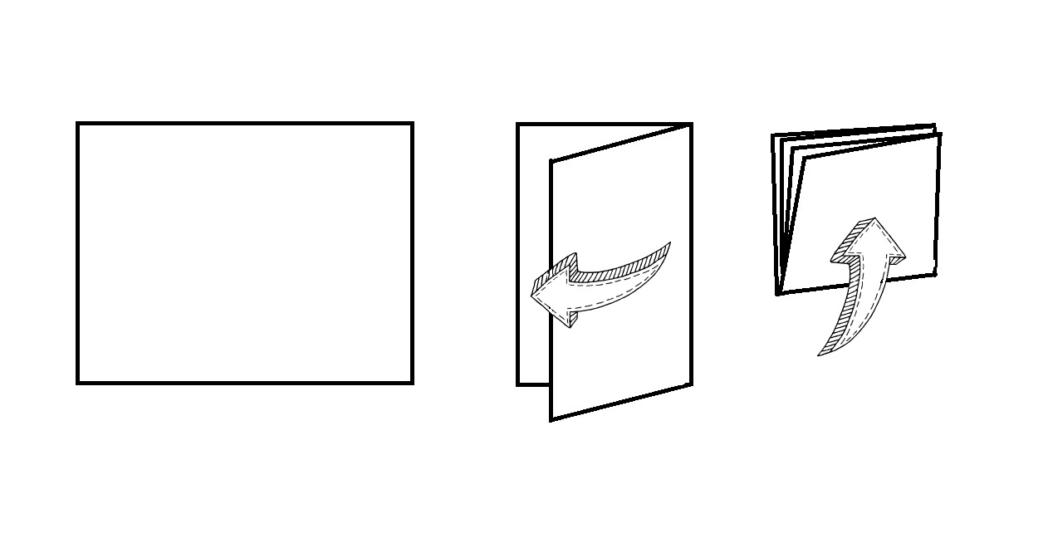

Grading – 35 points possible

Box 1: Block letters w/key terms 4 3 1 0

Box 2: Flowchart diagram 5 4 2 0

Box 3: Propaganda poster 3 1 0

Box 4: New weapons/contribution list 5 4 2 0

Box 5: Jane Schaeffer paragraph 6 5 4 3 2 1 0

Box 6: League of Nations debate t-chart 5 4 2 0

Box 7: AEF diary entry w/slang terms 5 4 2 0

Box 8: Something random 2 0

Total points earned: /35

