Assignment: Pre-Civil War Social Heroes
To demonstrate your understanding of the various social and political issues affecting the United States in the years prior to the Civil War (1840-1860).

Task: Choose two of the topics below then create an epitaph (tombstone/gravestone marker) for one and a HERO poster (opposite of a “Wanted” poster) for the other to display your learned knowledge on the person/event. Use text book pages 145 – 149; 158. Complete in spiral notebook.
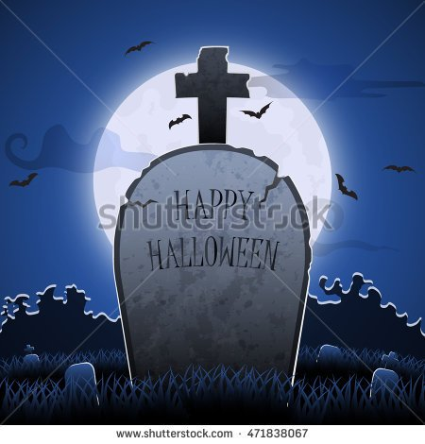
Topics
1. William Lloyd Garrison
2. Frederick Douglas
3. Nat Turner’s Rebellion &
Affect on Southerners
4. Women Mobilize for Reform
5. Seneca Falls Convention
6. Harriet Tubman

