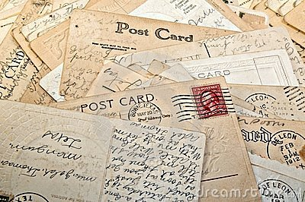
Postcard From the Past
A postcard is a photograph that people used to send while on vacation. It shows the people back home what they are missing and allows for a brief note.
Task: You will create a postcard that you would send home to tell your family about the innovative inventions and ideas for business that contributed to the Industrial Revolution at the end of the 19th and beginning of the 20th centuries. You will create 2 postcards choosing from the categories of invention, idea, strategy, or person; second postcard can NOT be the same category.
Steps:
1. Divide your spiral notebook page in half HORIZONTALLY.
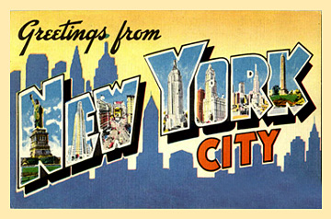
2. Trace the 4x6 index card onto the top half and bottom half. The top will be the front of the postcard; bottom will be the back of the postcard.
3. Create a design for the edge of the postcard – edging is the same for the front and back of postcard.
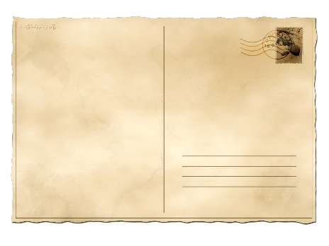
4. The front of your postcard has a large colored picture of your Industrial Revolution business invention, idea, strategy, or person AND an excited caption about it.
5. The back of your postcard describes/explains the innovative nature of your selected topic and your prediction of how it will affect the U.S.
6. The back of your postcard has a mailing stamp that represents the Industrial Revolution time period.
7. Choose a different category and repeat the process for the 2nd postcard on the next spiral page.

