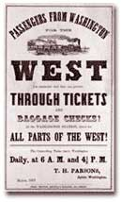
Manifest Destiny

Expansion westward seemed perfectly natural to many Americans in the mid-nineteenth century. Like the Massachusetts Puritans who hoped to build a "city upon a hill, "courageous pioneers believed that America had a divine obligation to stretch the boundaries of their noble republic to the Pacific Ocean. Independence had been won in the Revolution and reaffirmed in the War of 1812. The spirit of nationalism that swept the nation in the next two decades demanded more territory. The "every man is equal" mentality of the Jacksonian Era fueled this optimism. Now, with territory up to the Mississippi River claimed and settled and the Louisiana Purchase explored, Americans headed west in droves. It seemed perfectly natural to expand and settle westward. Newspaper editor John O’Sullivan is credited with the first person to use the term “manifest destiny” to encourage the spirit of expansionism and describe the essence of this mindset. Over the following years, the manifest destiny doctrine claimed that it should be the objective of the United States to absorb all of North America and Americans came to believe that the U.S. had a divine obligation to stretch its boundaries of their noble republic to the Pacific Ocean. This expansionism eventually ended in the acquisition of Texas, Oregon and California.
The religious fervor spawned by the Second Great Awakening created another incentive for the drive west. Indeed, many settlers believed that God himself blessed the growth of the American nation. The Native Americans were considered heathens. By Christianizing the tribes, American missionaries believed they could save souls and they became among the first to cross the Mississippi River.
Economic motives were paramount for others. The fur trade had been dominated by European trading companies since colonial times. German immigrant John Jacob Astor was one of the first American entrepreneurs to challenge the Europeans. He became a millionaire in the process. The desire for more land brought aspiring homesteaders to the frontier. When gold was discovered in California in 1848, the number of migrants increased even more.
At the heart of manifest destiny was the pervasive belief in American cultural and racial superiority. Native Americans had long been perceived as inferior, and efforts to "civilize" them had been widespread since the days of John Smith and Miles Standish. The Hispanics who ruled Texas and the lucrative ports of California were also seen as "backward."
Expanding the boundaries of the United States was in many ways a cultural war as well. The desire of southerners to find more lands suitable for cotton cultivation would eventually spread slavery to these regions. North of the Mason-Dixon line, many citizens were deeply concerned about adding any more slave states. Manifest destiny touched on issues of religion, money, race, patriotism, and morality. These clashed in the 1840s as a truly great drama of regional conflict began to unfold.
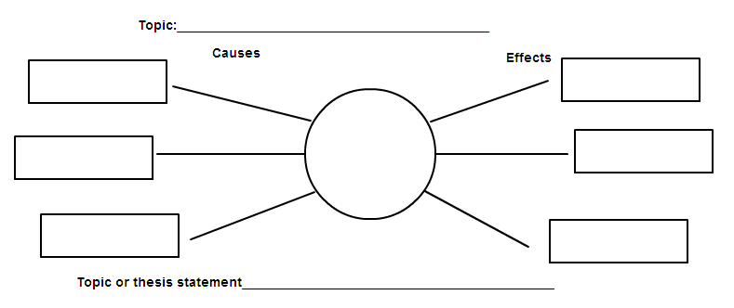
Directions: After reading the above information, complete the graphic organizer below. Draw out the graphic organizer IN YOUR SPIRAL NOTEBOOK!!

John L. O'Sullivan on Manifest Destiny, 1839

Excerpted from "The Great Nation of Futurity," The United States Democratic Review, Volume 6, Issue 23, pp. 426-430.

The American people having derived their origin from many other nations, and the Declaration of National Independence being entirely based on the great principle of human equality, these facts demonstrate at once our disconnected position as regards any other nation; that we have, in reality, but little connection with the past history of any of them, and still less with all antiquity, its glories, or its crimes. On the contrary, our national birth was the beginning of a new history, the formation and progress of an untried political system, which separates us from the past and connects us with the future only; and so far as regards the entire development of the natural rights of man, in moral, political, and national life, we may confidently assume that our country is destined to be the great nation of futurity.

The expansive future is our arena, and for our history. We are entering on its untrodden space, with the truths of God in our minds, beneficent objects in our hearts, and with a clear conscience unsullied by the past. The far-reaching, the boundless future will be the era of American greatness. In its magnificent domain of space and time, the nation of many nations is destined to manifest to mankind the excellence of divine principles; to establish on earth the noblest temple ever dedicated to the worship of the Most High -- the Sacred and the True.

This is our high destiny, and in nature's eternal, inevitable decree of cause and effect we must accomplish it. All this will be our future history, to establish on earth the moral dignity and salvation of man -- the immutable truth and beneficence of God. For this blessed mission to the nations of the world, which are shut out from the life-giving light of truth, has America been chosen; and her high example shall smite unto death the tyranny of kings, hierarchs, and oligarchs, and carry the glad tidings of peace and good will where myriads now endure an existence scarcely more enviable than that of beasts of the field. Who, then, can doubt that our country is destined to be the great nation of futurity?

Reading Analysis: Answer the following IN COMPLETE SENTENCES in your spiral.
1. Explain what John O’Sullivan assumed America was destined for. Cite evidence he used to support this claim.
2. What, according to O’Sullivan, was America’s future? Cite examples of what future America’s role shall be.
3. Interpret the author’s potential bias in this excerpt. Cite evidence with commentary to show such bias.

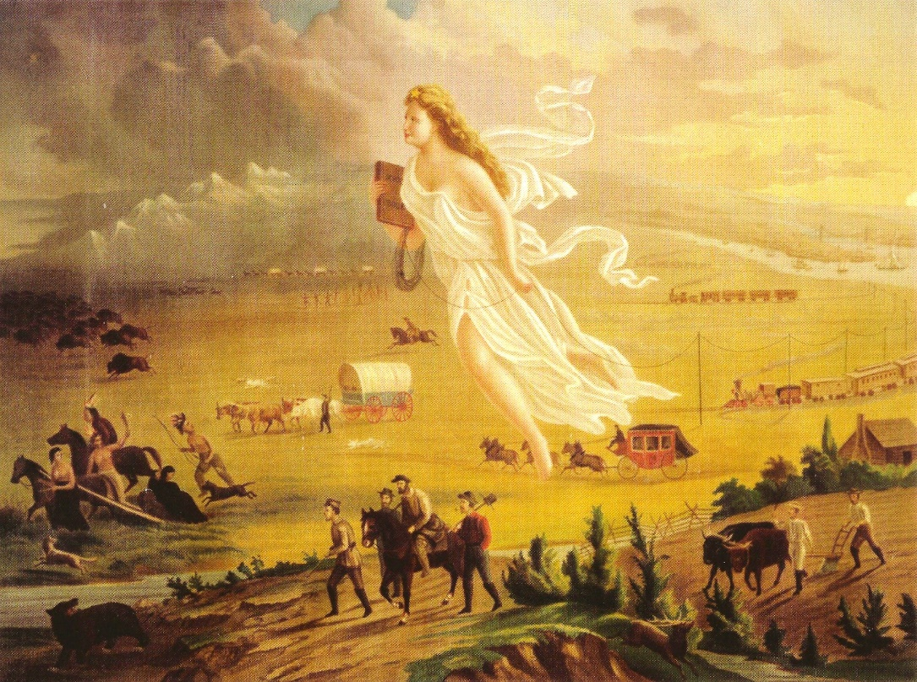
A symbol of Manifest Destiny, the figure "Columbia" moves across the land in advance of settlers, replacing darkness with light and ignorance with civilization.
Painting Analysis: Answer the following IN COMPLETE SENTENCES in your spirals.
1. Describe what actions are reflected in the painting by analyzing the background and the foreground of the painting.
2. How does the color variation contribute to the message of “manifest destiny?”
3. How does the painting relate to John O’Sullivan’s belief for America?

Paragraph Response: Write a paragraph with a topic sentence and 3 CDs (facts) in your spiral.
The theory that Americans are special is called “American Exceptionalism.” It’s this idea that America has had such a unique history and has become so powerful that there’s something really special about it. What do you think about this theory?

