IMMIGRATION TODAY (Extra Credit Assignment)
CENTRAL HISTORICAL QUESTION:
To what extent has anti-immigrant feelings changed since the turn of the century?

As review, at the turn of the 20th century, as the huddled masses of immigrants emigrated to the U.S., negative, anti-immigrant feelings emerged from native-born Americans. The immigrants became the target of discrimination, as well as, blamed for increases in social, economic, & political problems. Nativists disliked immigrants who wanted to keep their own culture and resentfulness turned to anger and hatred.
Do Americans harbor such feelings towards immigrants present-day? Debates over immigration reform commonly involve disputes over the costs and benefits of these immigrants to the society at large. Immigrants (both legal and unauthorized) have been viewed differently over time. A March 2013 survey from Pew Research, showed 49% of Americans believe that immigrants “strengthen the U.S. with their hard work and talents,” while 41% believe immigrants create “a burden because they take jobs and health care” resources. While undocumented U.S. residents often make significant contributions to the economy as a whole and their local communities, the political debate has partly focused on their perceived level of criminality. Estimates put the number of unauthorized immigrants in the United States at more than 10 million.
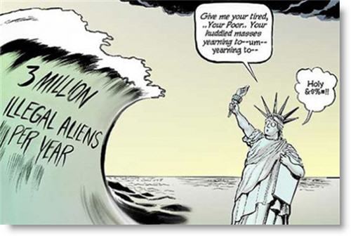
Task:
- Find a current political cartoon on immigration either on the Internet or in a newspaper or political magazine. You will need a copy of this cartoon for your assignment.

- Analyze the cartoon to determine its message about immigration.
3. Answer the following questions in complete sentences on a piece of paper that also includes a copy of the political cartoon:
a. What nationalities are the immigrants that are depicted?
b. How is the reader to know who the immigrants are? Are there historical or cultural symbols used to convey this knowledge to the reader?
c. What is the message the artist is trying to convey through the cartoon about the issue of immigration? Is there a negative connotation to the message (if so how?)
d. Respond to the following Essential Question in a Jane Schaefer one-chunk paragraph: To what extent has anti-immigrant feelings changed since the turn of the 20th century industrial revolution time period? Explain.

Points Possible: 13 extra credit points

