GRWS 16:4 America Moves Toward War
Read the textbook (pgs. 550 – 557) and answer the following questions in COMPLETE SENTENCES in your spirals.
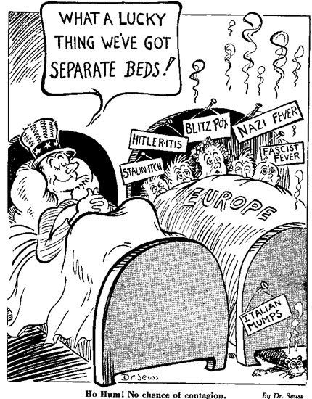
1. What policy went into effect as a result of the Neutrality Act of 1939? What justification did FDR argue in order for Congress to pass this policy?
2. What new jolted Americans in September 1940?
3. List 2 specific intentions of the Tripartite Pact.
4. How would declaring war on 1 of the Axis powers become America’s worst military nightmare?
5. What “cheeky” remark did Winston Churchill state referring to the U.S. sending weapons and leasing space on British military bases?
6. What tradition did President Roosevelt break? What year was he reelected?
7. What did FDR mean when he said, “No man can tame a tiger into a kitten by stroking it.”?
8. What warning was given to Congress by FDR to justify turning the U.S. into “the great arsenal of democracy”?
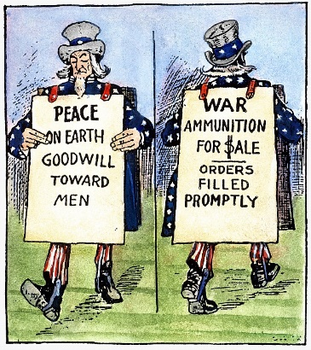
9. Explain the Lend-Lease Act (Include enacted date). Why did the U.S. enact this policy?
10. Explain the principle Roosevelt used to provide aid to the Soviet Union and Stalin?
11. What interfered with lend-lease deliveries (include dates of interference too)? What strategy was employed to disrupt the supply lines to Great Britain and Soviet Union?
12. Name the leaders met secretly aboard the USS Augusta. What was the outcome of the meeting?
13. How did the U.S. position of “neutrality” change after September 4, 1941?
14. Why was Japan able to expand easily in East Asia from 1937 – 1941?
15. Why was oil a critical good to embargo against Japan?
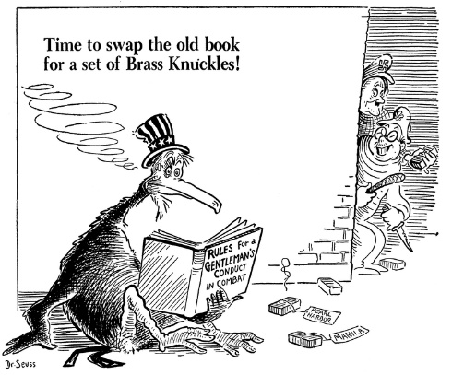
16. To what means did the U.S. discover Japan’s plans to attack the U.S.?
17. What message was sent by FDR’s “war warning”?
18. Why did Japan choose Pearl Harbor as its attack location against the U.S.? List the full date of the attack.
19. List the devastating results of the attack on Pearl Harbor.
20. How did Roosevelt refer to the attack on Pearl Harbor when asking Congress for a declaration of war?
21. Provide 2 specific examples of how WWII ended the Great Depression for the U.S.

