COLD WAR POLITICAL CARTOON ANALYSIS
1. Title your page “Cold War Political Cartoon Analysis”
2. Working w/an aisle partner, come up and grab 1 political cartoon with analysis questions. Use your PP notes & GRWS to help you analyze the Cold War events that are depicted in the cartoons.
3. Answer the questions in complete sentences in your spiral.
4. Skip 2 lines between each completed political cartoon’s analysis questions.
5. Complete all 6.

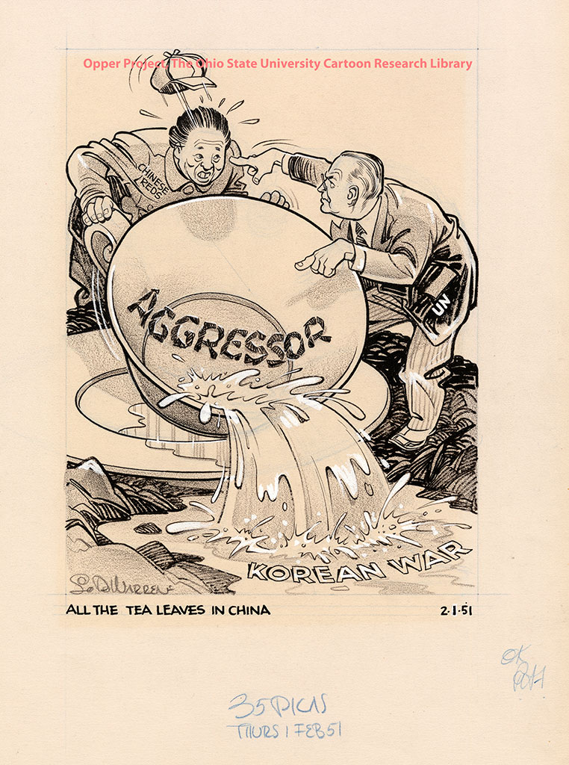

1. What is the cartoon’s title or caption?
2. Which countries, organizations or world leaders are depicted in this cartoon?
3. Editorial cartoonists combine pictures and words to communicate their opinions. What tools does the cartoonist use to make his or her point? List as many that apply from the following list of tools: Humor, Labels, Caricature, Symbols, Analogy to another event, Stereotypes, Speech Balloons, References to pop. culture, art, literature.
3. Describe what is going on in the cartoon.
4. What is the cartoon’s message about the situation in Korea?
5. What does the cartoon say about the United Nations?
6. What does the cartoon say about the USSR or other belligerent nations?

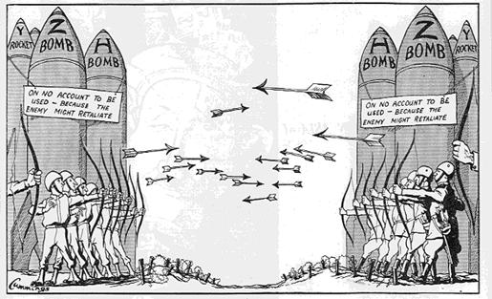

1. Which countries, organizations or world leaders are depicted in this cartoon?
2. Editorial cartoonists combine pictures and words to communicate their opinions. What tools does the cartoonist use to make his or her point? List as many that apply from the following list of tools: Humor, Labels, Caricature, Symbols, Analogy to another event, Stereotypes, Speech Balloons, References to pop. culture, art, literature.
3. Describe what is going on in the cartoon.
4. What is the cartoon’s message about the Cold War?
5. Create a title or caption for this cartoon.

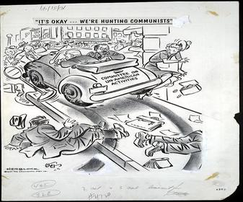

1. What is the cartoon’s title or caption?
2. Which countries, organizations or world leaders are depicted in this cartoon?
3. Editorial cartoonists combine pictures and words to communicate their opinions. What tools does the cartoonist use to make his or her point? List as many that apply from the following list of tools: Humor, Labels, Caricature, Symbols, Analogy to another event, Stereotypes, Speech Balloons, References to pop. culture, art, literature.
3. Describe what is going on in the cartoon.
4. What is the cartoon’s message about the actions of the HUAAC?
5. Create a new title or caption for this cartoon.

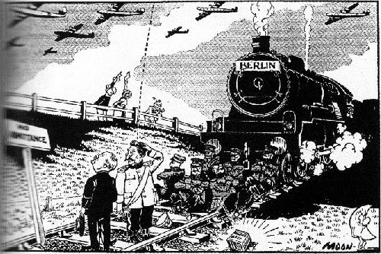

1. Which countries, organizations or world leaders are depicted in this cartoon?
2. Editorial cartoonists combine pictures and words to communicate their opinions. What tools does the cartoonist use to make his or her point? List as many that apply from the following list of tools: Humor, Labels, Caricature, Symbols, Analogy to another event, Stereotypes, Speech Balloons, References to pop. culture, art, literature.
3. Describe what is going on in the cartoon.
4. What Cold War event is the basis for the cartoon?
5. What does the cartoon say about the USA and Western Democracies?
6. What does the cartoon say about the USSR or other belligerent nations?

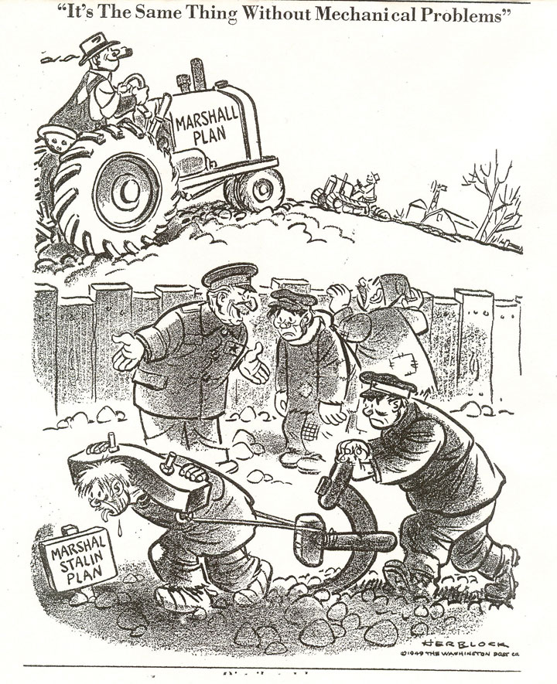

1. What is the cartoon’s title or caption?
2. Which countries, organizations or world leaders are depicted in this cartoon?
3. Editorial cartoonists combine pictures and words to communicate their opinions. What tools does the cartoonist use to make his or her point? List as many that apply from the following list of tools: Humor, Labels, Caricature, Symbols, Analogy to another event, Stereotypes, Speech Balloons, References to pop. culture, art, literature.
3. Describe what is going on in the cartoon.
4. What is the cartoon’s message about the Marshall Plan?

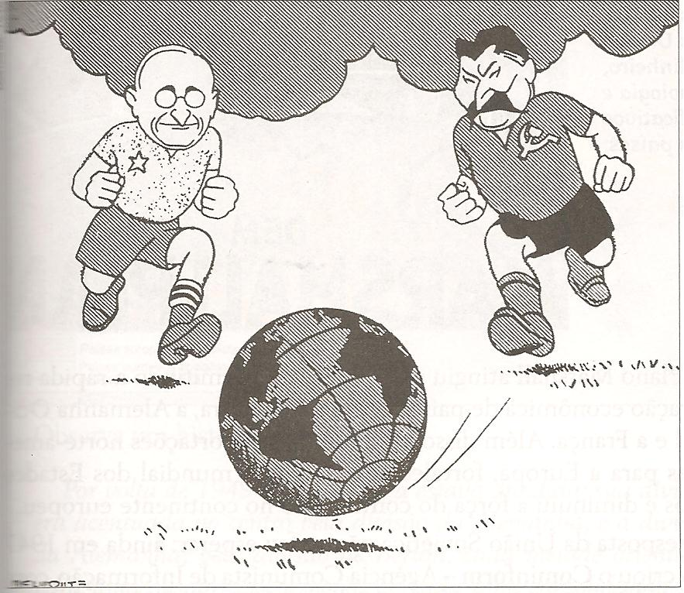

1. Which countries, organizations or world leaders are depicted in this cartoon?
2. Editorial cartoonists combine pictures and words to communicate their opinions. What tools does the cartoonist use to make his or her point? List as many that apply from the following list of tools: Humor, Labels, Caricature, Symbols, Analogy to another event, Stereotypes, Speech Balloons, References to pop. culture, art, literature.
3. Describe what is going on in the cartoon.
4. What is the cartoon’s message about the Cold War?
5. Create a title or caption for this cartoon.

