1920s Review Silhouettes
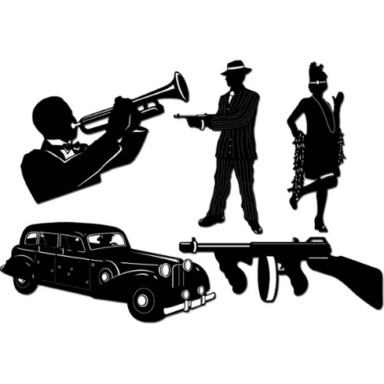
To review the vocab., key events, trends, people, changes, and arts & entertainment that occurred in the decade, you will create a silhouette visual.
Directions:
1. Google image search “1920s silhouettes”.
2. Choose two black shadow iconic images of the 1920s to print; images must be medium-sized on page. (4 pts)
3. Surround silhouettes with historically accurate Ch. 12-13 vocab., themes/trends, defining events, changes, people, and arts & entertainment associated with the 1920s decade. Word/phrases CAN NOT BE REPEATED!!(10 pts)
4. Each word/phrase MUST be a different color, varied sizes, and written neatly and creatively around the outside of the silhouettes. Words/phrases must take up all the blank space on the page. (10 pts)
5. Words/phrases can be written or typed around silhouette. If artistically capable, you can draw your own silhouette of 1920s iconic images rather than printing one from the Internet.
6. Silhouettes are due on Wednesday ~ worth 24 pts.
7. These directions are uploaded under the “documents” tab on my weebly site.

